# 联查双关联（内连接）

## 取出项目每年最大那个月的数据

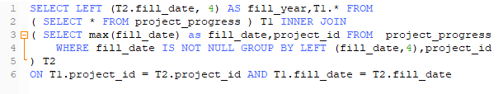

SELECT LEFT (T2.fill_date, 4) AS fill_year,T1.* FROM

( SELECT * FROM project_progress ) T1 INNER JOIN

( SELECT max(fill_date) as fill_date,project_id FROM project_progress

WHERE fill_date IS NOT NULL GROUP BY LEFT (fill_date,4),project_id

) T2

ON T1.project_id = T2.project_id AND T1.fill_date = T2.fill_date

# 分组查询

## 查询list



## 分开后List总数

